**HW 5**

**Mongo DB**

1. Database uploaded into MongoDB along with list of tables

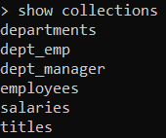

1. List of employees who were hired in 1985

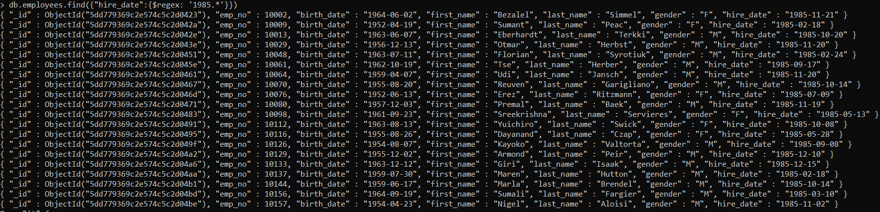

1. List of employees in Sales department

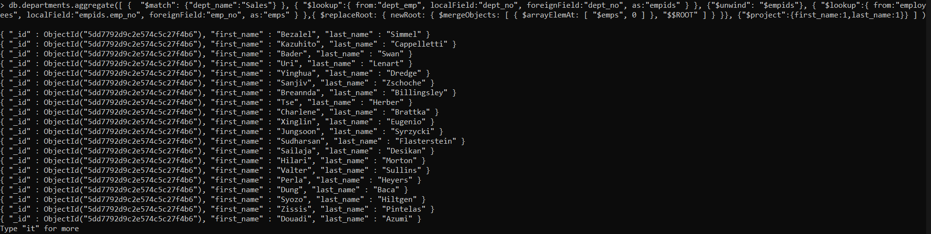

1. Count of employees in each department

